**Day 1**

System Software and Application Software.

**System Software:**

System software is a type of computer program designed to operate and control the hardware and provide a platform for running application software. It includes the operating system, device drivers, utility programs, and other essential software that manage the system's core functions, ensuring that the hardware and software components of a computer work together efficiently.

Functionality: It addresses user-specific tasks such as creating documents, managing data, and playing games.

**Examples of System Software:**

1. Operating Systems: Windows, macOS, Linux.
2. Device Drivers: Software that allows the operating system to communicate with hardware devices.
3. Utility Programs: Tools for system maintenance, such as disk cleanup, antivirus software, and backup tools.
4. Firmware: Embedded software in hardware devices that provides low-level control for the device's specific hardware.

**Application software:**

Application software is a type of computer program designed to help users perform specific tasks or activities. Unlike system software, which manages and operates computer hardware, application software is focused on user-oriented tasks and provides functionalities that directly fulfill user needs.

**Examples of Application Software:**

1. Productivity Software: Word processors (e.g., Microsoft Word), spreadsheets (e.g., Microsoft Excel), and presentation tools (e.g., PowerPoint).
2. Media Software: Image editors (e.g., Adobe Photoshop), video players (e.g., VLC Media Player), and music players (e.g., iTunes).
3. Communication Software: Email clients (e.g., Microsoft Outlook), messaging apps (e.g., Slack), and video conferencing tools (e.g., Zoom).
4. Web Browsers: Google Chrome, Mozilla Firefox, Safari.

**Day 2**

Case Study on Client Server and SOA.

**Client Server:**

Client-Server Architecture is a network model that allows different applications to exchange data and communicate over a network. It is widely used for network applications such as email, web, online banking, e-commerce, etc.

This model divides the system into two parts: a client and a server.

The client is the application that requests services from the server, such as retrieving or storing data, performing calculations, or executing commands.

The server is the application that provides services to the client, such as processing requests, sending responses, or completing actions.

**How does Client-Server Architecture work?**

The basic steps of how Client-Server Architecture works are:

* In the first step, client sends a request to the server using the network medium. The request can be a query, a command, or a message.
* In the second step, the server receives the request and processes it according to its logic and data. The server may access its own resources or other servers to fulfil the request.
* In the third step, server sends a response back to the client using the network medium. The response can be data, an acknowledgement, or an error message.
* Lastly, client receives the response and displays it to the user or performs further actions based on it.

To explore this through a case study, let's consider an example of an online retail company, "**Retail Tech**."

**Overview**

Retail Tech is an online retail company that leverages a client-server architecture to manage its online store Retail Tech, customer data, and inventory. The company has a web application through which customers can browse products, make purchases, and track their orders.

**Components**

**1.Client Side**

* **Web Browsers:** Customers use web browsers to access the Retail Tech website. These browsers act as clients that request web pages and services from the server.
* **Mobile Apps**: Retail Tech also has mobile application ns for iOS and Android. These apps also act as clients, sending requests to the server for product listings, user authentication, and order processing.

**2.Server Side**

* **Web Server:** Handles incoming HTTP requests from clients, serves web pages, and manages user sessions.
* **Application Server:** Runs the core business logic of Retail Tech. It processes client requests, interacts with the database, and returns the required data to the client.
* **Database Server:** Stores all the data related to products, customers, orders, and inventory. It uses a relational database management system to manage data.
* **Authentication Server:** Manages user authentication and authorization, ensuring that only registered users can make purchases and access their account details.
* **Load Balancer:** Distributes incoming network traffic across multiple web and application servers to ensure high availability and reliability.

**Benefits of Client-Server Architecture for Retail Tech**

* Scalability: Retail Tech can add more servers (web, application, or database) to handle increased load as the business grows.
* Centralized Management: All the critical business logic and data are managed centrally, making it easier to maintain and update.
* Security: Sensitive information, such as user credentials and payment details, are securely handled by the authentication server.
* Performance: The use of a load balancer ensures that traffic is distributed evenly, preventing any single server from becoming a bottleneck.

**Challenges of Client-Server Architecture for Retail Tech**

* Single Point of Failure: If the central server (especially the database server) goes down, the entire system can become unavailable. This can be mitigated through redundancy and failover mechanisms.
* Complexity: Setting up and maintaining a client-server architecture can be complex, requiring skilled IT personnel.
* Latency: The time taken to process a request and deliver a response can be affected by network latency and server load, impacting user experience.

**UML Diagram**

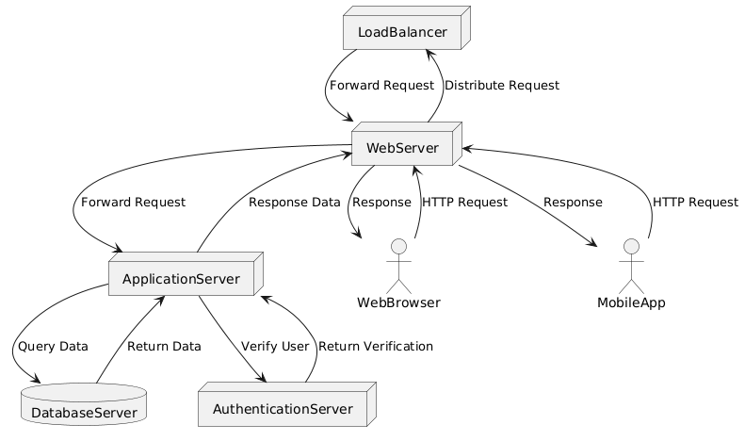

**Service-Oriented Architecture:**

Service-oriented architecture (SOA) is a method of software development that uses software components called services to create business applications. Each service provides a business capability, and services can also communicate with each other across platforms and languages. Developers use SOA to reuse services in different systems or combine several independent services to perform complex tasks.

**Implementation of SOA**

SOA is independent of vendors and technologies. This means a variety of products can be used to implement the architecture. The decision of what to use depends on the goal of the system.

SOA is typically implemented with web services such as simple object access protocol (SOAP) and web services description language (WSDL). Other available implementation options include Windows Communication Foundation; g RPC; and messaging, such as with Java Message Service ActiveMQ and RabbitMQ.

SOA implementations can use one or more protocols and may also use a file system tool to communicate data. The protocols are independent of the underlying platform and programming language. The key to a successful implementation is the use of independent services that perform tasks in a standardized way without needing information about the calling application or the calling application requiring knowledge of the tasks the service performs.

**Case Study: E-commerce Platform**

**Business Context:**

A large e-commerce company wants to improve its scalability, flexibility, and integration capabilities across various systems and partners. They decide to implement SOA to achieve these goals.

**Components and Services:**

1. **Order Management Service:** Responsible for handling order processing, inventory management, and shipment tracking.
2. **Customer Management Service:** Manages customer profiles, authentication, and personalized recommendations.
3. **Payment Service:** Handles payment processing, integrates with different payment gateways.
4. **Product Catalog Service:** Manages product information, pricing, and availability.

**Architecture Design:**

* **Service Layer:** Each service is designed to be independent and self-contained, exposing APIs for communication.
* **Integration Layer:** Mediates communication between services using protocols like REST, SOAP, or messaging queues.
* **Orchestration Layer:** Coordinates service interactions to fulfill complex business processes, such as order fulfillment or personalized offers.

**Benefits:**

* **Flexibility:** Services can be updated or replaced without affecting the entire system.
* **Scalability:** Each service can scale independently based on demand.
* **Integration:** Simplifies integration with external systems and third-party services.

**Challenges:**

* **Complexity:** Managing a large number of services and their interactions requires careful design and governance.
* **Performance**: Increased network communication between services can impact performance if not optimized.

**Component Diagram:**

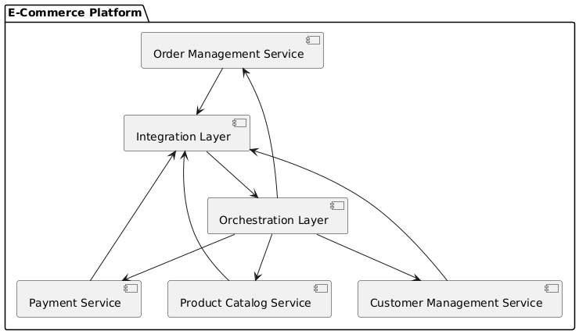

**Sequence Diagram**:

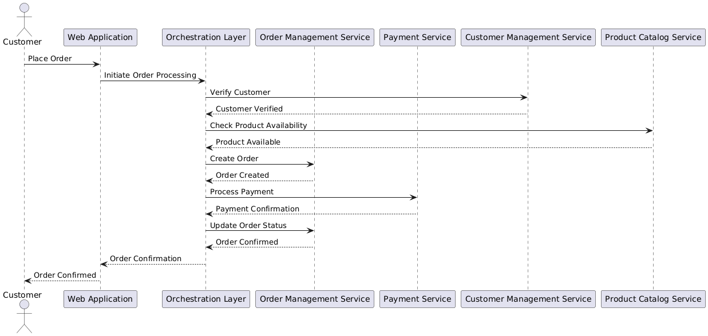

**Day 3**

PPt presentation

**Day 4**

Software design patterns are established solutions to common design problems that software developers face. They are templates or best practices for designing software architectures and solving issues in a way that is both effective and reusable. Here’s a detailed overview of some of the most important design patterns, categorized into three main types: Creational, Structural, and Behavioural.

**1. Creational Design Patterns**

Creational patterns focus on how objects are created. They abstract the instantiation process, making it more flexible and efficient.

**Singleton**

- **Purpose**: Ensures that a class has only one instance and provides a global point of access to it.

  - **Example**: A configuration manager that reads configuration settings from a file.

  - **Example Code (Java)**:

    ```java

    public class Singleton {

        private static Singleton instance;

        private Singleton() {}

        public static Singleton getInstance() {

            if (instance == null) {

                instance = new Singleton();

            }

            return instance;

        }

    }

**```**

**- **Factory Method\*\***

  - **Purpose**: Defines an interface for creating objects, but allows subclasses to alter the type of objects that will be created.

  - **Example**: A document creation application where the type of document (Word, PDF, etc.) is decided at runtime.

  - **Example Code (Java)**:

    ```java

    abstract class Document {

        abstract void create();

    }

    class WordDocument extends Document {

        @Override

        void create() {

            System.out.println("Creating a Word document.");

        }

    }

    class DocumentFactory {

        public Document createDocument(String type) {

            if (type.equals("Word")) {

                return new WordDocument();

            }

            // Additional types can be added here

            return null;

        }

    }

**- **Abstract Factory\*\***

- **Purpose**: Provides an interface for creating families of related or dependent objects without specifying their concrete classes.

  - **Example**: Creating user interfaces with different themes (light mode, dark mode).

  - **Example Code (Java)**:

    ```java

    interface GUIFactory {

        Button createButton();

        Checkbox createCheckbox();

    }

    class WinFactory implements GUIFactory {

        public Button createButton() { return new WinButton(); }

        public Checkbox createCheckbox() { return new WinCheckbox(); }

    }

    class MacFactory implements GUIFactory {

        public Button createButton() { return new MacButton(); }

        public Checkbox createCheckbox() { return new MacCheckbox(); }

    }

    ```

**- **Builder\*\***

  - **Purpose**: Separates the construction of a complex object from its representation so that the same construction process can create different representations.

  - **Example**: Building a complex meal with different combinations of dishes.

  - **Example Code (Java)**:

    ```java

    class Meal {

        private String mainCourse;

        private String drink;

        public void setMainCourse(String mainCourse) { this.mainCourse = mainCourse; }

        public void setDrink(String drink) { this.drink = drink; }

    }

    abstract class MealBuilder {

        protected Meal meal = new Meal();

        public abstract void buildMainCourse();

        public abstract void buildDrink();

        public Meal getMeal() { return meal; }

    }

    class VegMealBuilder extends MealBuilder {

        public void buildMainCourse() { meal.setMainCourse("Vegetarian Burger"); }

        public void buildDrink() { meal.setDrink("Lemonade"); }

    }

    ```

**- **Prototype\*\***

  - **Purpose**: Creates new objects by copying an existing object, known as the prototype.

  - **Example**: Copying objects with default settings for a new configuration.

  - **Example Code (Java)**:

    ```java

    interface Prototype {

        Prototype clone();

    }

    class ConcretePrototype implements Prototype {

        @Override

        public Prototype clone() {

            return new ConcretePrototype();

        }

    }

    ```

**### 2. **Structural Design Patterns\*\***

Structural patterns focus on how objects and classes are composed to form larger structures.

- **Adapter (or Wrapper)**

  - **Purpose**: Allows incompatible interfaces to work together.

  - **Example**: Adapting a legacy system interface to a new system.

  - **Example Code (Java)**:

    ```java

    interface Target {

        void request();

    }

    class Adaptee {

        void specificRequest() {

            System.out.println("Specific request.");

        }

    }

    class Adapter implements Target {

        private Adaptee adaptee;

        public Adapter(Adaptee adaptee) { this.adaptee = adaptee; }

        public void request() { adaptee.specificRequest(); }

    }

**```**

**- **Decorator\*\***

- **Purpose**: Adds new functionality to an object without altering its structure.

  - **Example**: Adding scroll bars to a window.

  - **Example Code (Java)**:

    ```java

    interface Window {

        void draw();

    }

    class SimpleWindow implements Window {

        public void draw() {

            System.out.println("Drawing a simple window.");

        }

    }

    abstract class WindowDecorator implements Window {

        protected Window decoratedWindow;

        public WindowDecorator(Window decoratedWindow) { this.decoratedWindow = decoratedWindow; }

        public void draw() { decoratedWindow.draw(); }

    }

    class ScrollableWindow extends WindowDecorator {

        public ScrollableWindow(Window decoratedWindow) { super(decoratedWindow); }

        public void draw() {

            super.draw();

            System.out.println("Adding scroll bars.");

        }

    }

**```**

**- **Composite\*\***

  - **Purpose**: Allows clients to treat individual objects and compositions of objects uniformly.

  - **Example**: A file system where files and directories are treated similarly.

  - **Example Code (Java)**:

    ```java

    interface Component {

        void operation();

    }

    class Leaf implements Component {

        public void operation() {

            System.out.println("Leaf operation.");

        }

    }

    class Composite implements Component {

        private List<Component> children = new ArrayList<>();

        public void add(Component component) { children.add(component); }

        public void operation() {

            for (Component child : children) {

                child.operation();

            }

        }

    }

    ```

**- **Facade\*\***

  - **Purpose**: Provides a simplified interface to a complex subsystem.

  - **Example**: A simplified API for a complex library.

  - **Example Code (Java)**:

    ```java

    class SubsystemA {

        void operationA() { System.out.println("Subsystem A operation."); }

    }

    class SubsystemB {

        void operationB() { System.out.println("Subsystem B operation."); }

    }

    class Facade {

        private SubsystemA a = new SubsystemA();

        private SubsystemB b = new SubsystemB();

        public void performOperation() {

            a.operationA();

            b.operationB();

        }

    }

    ```

**- **Bridge\*\***

  - **Purpose**: Decouples an abstraction from its implementation so that the two can vary independently.

  - **Example**: Drawing different shapes (circle, square) in different colors.

  - **Example Code (Java)**:

    ```java

    interface DrawingAPI {

        void drawCircle(int x, int y, int radius);

    }

    class ConcreteDrawingAPI1 implements DrawingAPI {

        public void drawCircle(int x, int y, int radius) {

            System.out.println("Drawing API 1: Circle at (" + x + ", " + y + ") with radius " + radius);

        }

    }

    class Circle {

        private int x, y, radius;

        private DrawingAPI drawingAPI;

        public Circle(int x, int y, int radius, DrawingAPI drawingAPI) {

            this.x = x; this.y = y; this.radius = radius; this.drawingAPI = drawingAPI;

        }

        public void draw() {

            drawingAPI.drawCircle(x, y, radius);

        }

    }

    ```

**- **Proxy\*\***

  - **Purpose**: Provides a surrogate or placeholder for another object.

  - **Example**: A proxy that manages access to a resource-heavy object.

  - **Example Code (Java)**:

    ```java

    interface Image {

        void display();

    }

    class RealImage implements Image {

        private String filename;

        public RealImage(String filename) { this.filename = filename; }

        public void display() { System.out.println("Displaying " + filename); }

    }

    class ProxyImage implements Image {

        private RealImage realImage;

        private String filename;

        public ProxyImage(String filename) { this.filename = filename; }

        public void display() {

            if (realImage == null) {

                realImage = new RealImage(filename);

            }

            realImage.display();

        }

    }

    ```

**### 3. **Behavioral Design Patterns\*\***

Behavioral patterns focus on communication between objects and how responsibilities are distributed.

- **Chain of Responsibility**

  - **Purpose**: Passes a request along a chain of potential handlers until one of them handles it.

  - **Example**: A help desk where requests are escalated through different levels.

  - **Example Code (Java)**:

    ```java

    abstract class Handler {

        private Handler next;

        public void setNext(Handler next) { this.next = next; }

        public void handleRequest(int request) {

            if (next != null) {

                next.handleRequest(request);

            }

        }

    }

    class ConcreteHandlerA extends Handler {

        public void handleRequest(int request) {

            if (request < 10) {

                System.out.println("Handler A handled request " + request);

            } else {

                super.handleRequest(request);

            }

**Cloud Computing**

Cloud computing is a revolutionary technology that enables the delivery of computing services over the internet. It offers scalable resources on demand, ranging from computing power and storage to advanced services like AI and big data analytics. This guide will cover everything you need to know about cloud computing, including its types, key services, architectures, best practices, and real-world use cases.

**1. What is Cloud Computing?**

Cloud computing provides a range of IT resources and services over the internet. Instead of owning and maintaining physical hardware and software, users access computing resources on a pay-as-you-go basis.

**\*\*Key Characteristics of Cloud Computing\*\***

| **Characteristic**       | **Description**                                                                                   |

| **On-Demand Self-Service** | Users can provision computing capabilities as needed without human intervention from service providers. |

| **Broad Network Access** | Services are available over the network and can be accessed from various devices (smartphones, tablets, PCs). |

| **Resource Pooling**    | Providers pool computing resources to serve multiple consumers using a multi-tenant model.       |

| **Rapid Elasticity**   | Resources can be scaled up or down quickly based on demand.                                       |

| **Measured Service**   | Resource usage is measured, and users are billed based on their consumption.                       |

**### **Benefits of Cloud Computing\*\***

- **Cost Efficiency**: Reduces upfront capital expenditures and offers a pay-as-you-go model.

- **Scalability**: Easily scale resources up or down based on demand.

- **Flexibility**: Access resources and services from anywhere at any time.

- **Automatic Updates**: Cloud providers handle software updates and maintenance.

- **Disaster Recovery**: Cloud solutions often include backup and disaster recovery options.

**---**

**## 2. **Types of Cloud Computing Services\*\***

Cloud computing offers various services, which can be categorized into three main types:

**### **2.1 Service Models\*\***

| **Model**       | **Description**                                                                                              |

|-----------------|--------------------------------------------------------------------------------------------------------------|

| **Infrastructure as a Service (IaaS)** | Provides virtualized computing resources over the internet, including servers, storage, and networking. |

| **Platform as a Service (PaaS)**      | Offers hardware and software tools over the internet, typically for application development.                |

| **Software as a Service (SaaS)**      | Delivers software applications over the internet on a subscription basis.                    **|**

**#### **IaaS Example Providers\*\***

| **Provider**     | **Description**                                                            |

|------------------|----------------------------------------------------------------------------|

| **Amazon Web Services (AWS)** | Offers services like EC2, S3, and VPC.                                       |

| **Microsoft Azure**         | Provides VMs, Blob Storage, and Virtual Networks.                              |

| **Google Cloud Platform (GCP)** | Includes Compute Engine, Cloud Storage, and VPC.                              |

**#### **PaaS Example Providers\*\***

| **Provider**     | **Description**                                                            |

|------------------|----------------------------------------------------------------------------|

| **Heroku**       | Provides a platform for building and running apps.                          |

| **Google App Engine** | A fully managed PaaS for app deployment and scaling.                      |

| **Microsoft Azure App Services** | Offers web apps, mobile backends, and RESTful APIs.                    |

**#### **SaaS Example Providers\*\***

| **Provider**       | **Description**                                                       |

|--------------------|-----------------------------------------------------------------------|

| **Google Workspace** | Includes Gmail, Docs, Drive, and Calendar.                           |

| **Salesforce**     | Provides CRM solutions and business apps.                             |

| **Office 365**     | Offers productivity tools like Word, Excel, and Outlook.              |

**### **2.2 Deployment Models\*\***

| **Model**             | **Description**                                                                                               |

|-----------------------|---------------------------------------------------------------------------------------------------------------|

| **Public Cloud**     | Services are offered over the public internet and shared among multiple organizations.                     |

| **Private Cloud**    | Services are maintained on a private network and used exclusively by a single organization.                 |

| **Hybrid Cloud**     | A combination of public and private clouds, allowing data and applications to be shared between them.       |

| **Community Cloud**  | Shared infrastructure for a specific community of organizations with common concerns.                    **|**

**---**

**## 3. **Cloud Computing Architectures\*\***

### **3.1 Basic Architecture**

| **Component**       | **Description**                                                                             |

|--------------------|---------------------------------------------------------------------------------------------|

| **Cloud Provider** | Company offering cloud services (e.g., AWS, Azure, Google Cloud).                          |

| **Cloud Users**    | Individuals or organizations that use cloud services.                                       |

| **Service Models** | IaaS, PaaS, SaaS models providing different levels of service.                              |

| **Infrastructure** | Physical data centers and virtual resources like servers, storage, and networks.            |

**\*\*Basic Cloud Computing Architecture Diagram:\*\***

![Basic Cloud Computing Architecture](https://cloud.google.com/images/architecture/architecture-4x3-1-1-1.png)

Source: Google Cloud

**### **3.2 Components of Cloud Architecture\*\***

| **Component**    | **Description**                                                                 |

|------------------|---------------------------------------------------------------------------------|

| **Compute**      | Virtual machines, containers, or serverless functions.                          |

| **Storage**      | File storage, block storage, and object storage solutions.                      |

| **Networking**   | Virtual private clouds, load balancers, and DNS management.                     |

| **Databases**    | Relational databases, NoSQL databases, and data warehousing solutions.          |

| **Security**     | Identity management, encryption, and security monitoring.                         |

| **Management**   | Tools for monitoring, billing, and orchestrating cloud resources.                |

### **3.3 Cloud Computing Models**

| **Model**     | **Description**                                                                                             |

|---------------|-------------------------------------------------------------------------------------------------------------|

| **Serverless**| Running applications without managing servers. Examples: AWS Lambda, Azure Functions, Google Cloud Functions. |

| **Containers** | Encapsulating applications and dependencies in containers. Examples: Docker, Kubernetes.                |

---

**## 4. **Cloud Computing Best Practices\*\***

**### **4.1 Security Best Practices\*\***

| **Practice**        | **Description**                                                                                             |

| **Use IAM Roles**   | Implement Identity and Access Management (IAM) roles for secure access controls.                           |

| **Encrypt Data**   | Encrypt data at rest and in transit to protect sensitive information.                                      |

| **Regular Updates**| Keep your systems and applications up-to-date with the latest security patches.                           |

| **Monitor Activity**| Implement logging and monitoring to detect and respond to suspicious activities. **|**

| **Backup Data**    | Regularly backup data and ensure recovery procedures are in place.                                         |

**### **4.2 Cost Management\*\***

| **Practice**           | **Description**                                                                                             |

|-----------------------|-------------------------------------------------------------------------------------------------------------|

| **Right-Sizing Resources** | Allocate resources based on actual needs to avoid over-provisioning and reduce costs.                  |

| **Use Reserved Instances** | Commit to using resources for a longer term to receive discounts.                                        |

| **Monitor Billing**    | Regularly review billing statements and set up alerts for unexpected charges.                            |

| **Optimize Storage Costs** | Use cost-effective storage solutions and manage data lifecycle policies.                                  |

**### **4.3 Performance Optimization\*\***

| **Practice**            | **Description**                                                                                             |

|------------------------|-------------------------------------------------------------------------------------------------------------|

| **Auto-Scaling**       | Implement auto-scaling to adjust resources based on demand.                                               |

| **Load Balancing**     | Distribute workloads across multiple servers or instances for better performance and availability.       |

| **Optimize Applications** | Fine-tune application performance for better efficiency.                                                |

| **Monitor Performance** | Use tools for performance monitoring and optimization.                                                      |

**### **4.4 Compliance and Governance\*\***

| **Practice**           | **Description**                                                                                             |

|-----------------------|-------------------------------------------------------------------------------------------------------------|

| **Adhere to Regulations** | Ensure compliance with industry regulations and standards.                                               |

| **Implement Policies** | Establish cloud governance policies for resource management and security.                                |

| **Audit Regularly**   | Perform regular audits to ensure compliance and security measures are effective.                          |

---

**## 5. **Real-World Use Cases of Cloud Computing\*\***

**### **5.1 Web Hosting\*\***

- **Use Case**: Hosting websites and web applications.

- **Example**: Hosting an e-commerce site using AWS EC2 instances and S3 for static content.

**### **5.2 Data Backup and Disaster Recovery\*\***

- **Use Case**: Protecting data and ensuring business continuity.

- **Example**: Using Google Cloud Storage for backups and Google Cloud Disaster Recovery services.

**### **5.3 Application Development\*\***

- **Use Case**: Building, testing, and deploying applications.

- **Example**: Developing a mobile app with Azure App Services and integrating with Azure SQL Database.

**### **5.4 Big Data Analytics\*\***

- **Use Case**: Analyzing large datasets for insights and decision-making.

- **Example**: Using AWS Redshift for data warehousing and analyzing user behavior.

**### **5.5 Machine Learning and AI\*\***

- **Use Case**: Building and deploying machine learning models.

- **Example**: Using Google AI Platform to train and deploy machine learning models for predictive analytics.

**### **5.6 IoT Solutions\*\***

- **Use Case**: Managing and analyzing data from Internet of Things (IoT) devices.

- **Example**: Using Azure IoT Hub to connect and manage IoT devices, and Azure Stream Analytics for data processing.

**### **5.7 DevOps and CI/CD\*\***

- **Use Case**: Automating the development and deployment pipelines.

- **Example**: Using AWS CodePipeline for continuous integration and delivery.